**Lab 3: Linear Power Supply with Zener Regulation**

EE 3310L

Spring 2023

**Alex Yeoh**

Cauy Gibson

Submitted to TA: C. Hicks Friday 8:27 AM

Date of Experiment: 02/03/23

Date of Submission 02/10/23

1. **Introduction**

The purpose of this lab is to construct a three-transistor circuit and measure its operating voltages and currents to verify that all transistors are in the active region and thus capable of small-signal linear amplification [1].

1. **Experimental Methodology**

The first step of the experiment is constructing the circuit following figure 1 below, while ensuring that none of the transistors have an hFE less than 30 [1].

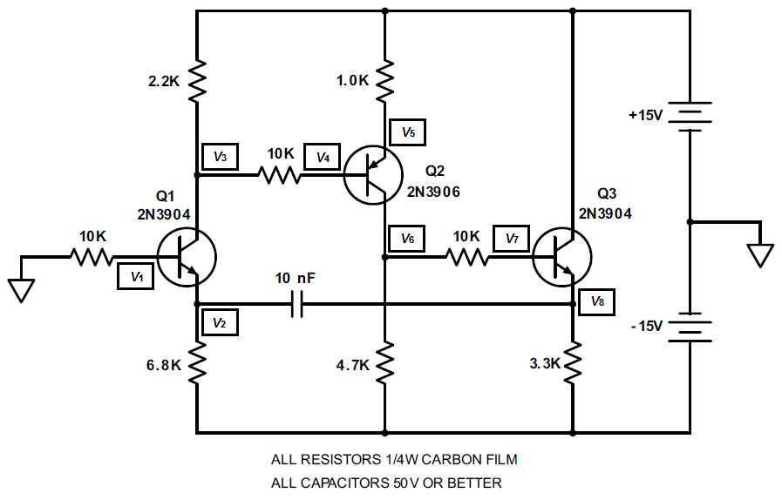

Figure 1. Circuit for exploring the waveform of a full-wave-rectified sine wave.

Each of the nodes then have their voltage measured and compared against the given table of node voltages as seen below in table 1, to ensure measured values are reasonably close [1].

Table 1: Given table of node voltages.



1. **Results and Description**

The measured node voltages for the circuit seen in figure 1 above with transistor hFE values of 201, 226, and 130 for transistors Q1, Q2, and Q3 respectively can be seen in table 2 below.

Table 2: Measured node voltages.



1. **Discussion**

The calculated values for VB, VC, VE, VBE, VCE, IB, IC, IE, and ß for transistors Q1, Q2, and Q3 can be seen in table 3 below.

Table 3: Calculated voltages, currents and ßs.

VB, VC, VE for each transistor is from their respective measured node voltages. VBE is calculated from equation 1 below.

$V_{BE}=V_{B}-V_{E}$ (1)

VCE is calculated from equation 2 below.

$V_{CE}=V_{C}-V_{E}$ (2)

IB1 is calculated from equation 3 below. It is in this order to show that current is flowing towards the transistor.

$I_{B1}=\frac{(0-V_{B1})}{10000}$ (3)

IB2 is calculated from equation 4 below. It is in this order to show that current is flowing away from the transistor.

$I_{B2}=\frac{(V_{B2}-V_{C1})}{10000}$ (4)

IB3 is calculated from equation 5 below. It is in this order to show that current is flowing towards the transistor.

$I_{B3}=\frac{(V_{C2}-V_{B3})}{10000}$ (5)

IB1 is calculated from equation 6 below. It is in this order to show that current is flowing away from the transistor.

$I_{E1}=\frac{(V_{E1}-(-15))}{6800}$ (6)

IB2 is calculated from equation 7 below. It is in this order to show that current is flowing towards the transistor.

$I_{E2}=\frac{(15-V_{E2})}{1000}$ (7)

IB3 is calculated from equation 8 below. It is in this order to show that current is flowing away from the transistor.

$I_{E3}=\frac{(V_{E3}-(-15))}{3300}$ (8)

Due to each measured transistor having a ß value greater than 100, which means they have a sufficiently high ß value, IC can be determined from equation 9 below.

$I_{C}=I_{E}$ (9)

ß values for each transistor can be calculated with equation 10 below.

$ß=\frac{I_{C}}{I_{B}}$ (10)

The calculated ß1 is similar to the measured ß value for Q1. ß2, however, is much larger than the measured ß value for Q2 and ß3 is moderately larger than the measured ß value for Q3.

A Multisim circuit simulation of the circuit from figure 1 with the mentioned ß values from the first paragraph of results and description can be seen below in figure 2.

Figure 2: Multisim simulation of the circuit from figure 1.

The simulated node voltages on Multisim show that the simulated and measured node voltages were generally similar, except for voltages 6, 7, and 8 where the simulated voltages were a fair bit lower than the experimental values.

1. **Summary and Conclusions**

The most of lab itself is simple and straightforward to complete due to the instructions given. The lab was unclear about measuring the currents of the circuit as it was not mentioned in the procedure section and only mentioned in the postlab section. As such, for question 3 of the postlab, ß values were calculated with the calculated currents instead of measured currents.

**Reference**

[1] Tritschler, Joe. "BJT Voltages and Currents." N.p., n.d. Web. 03 Feb 2023.